Replacing a Word Using LEX

Aim
To write a LEX program to replace the word hello with hi in the given input text.

Algorithm
- Start the program.
- Read the input text.
- Identify the word hello using a LEX rule.
- Replace hello with hi.
- Print the modified text.
- Stop the program.

Pseudocode
BEGIN
Read input text
WHILE characters are available
IF word "hello" is found
Print "hi"
ELSE
Print the original character
END IF
END WHILE
STOP
END

Program (replace.l)
%{
#include <stdio.h>
%}
%%
hello { printf("hi"); }
.|\n { printf("%s", yytext); }
%%
int yywrap(void)
{
return 1;
}
int main(void)
{
yylex();
return 0;
}
Input
hello everyone
welcome to hello world
Output
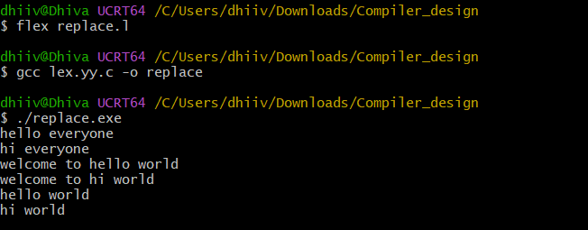

Result
Thus, the LEX program successfully replaces the word hello with hi in the given input text.

